Instruction
- Install the required modules.
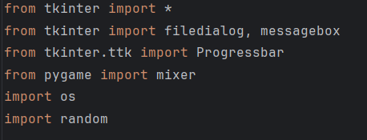
- Run the app.
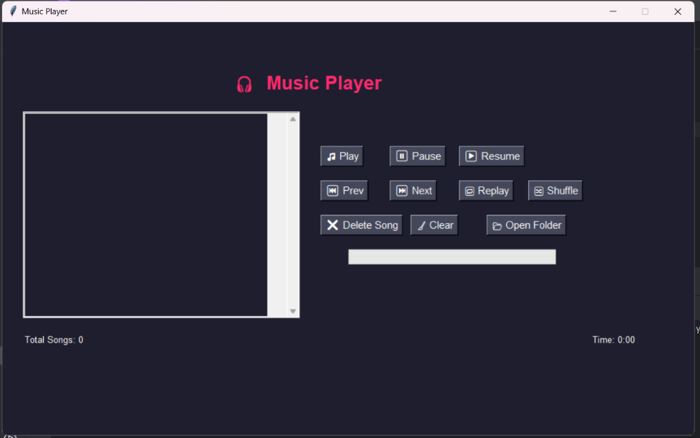

Features:
How to Use the Application

Open folder Click the “Open folder” button and select multiple `.mp3` files
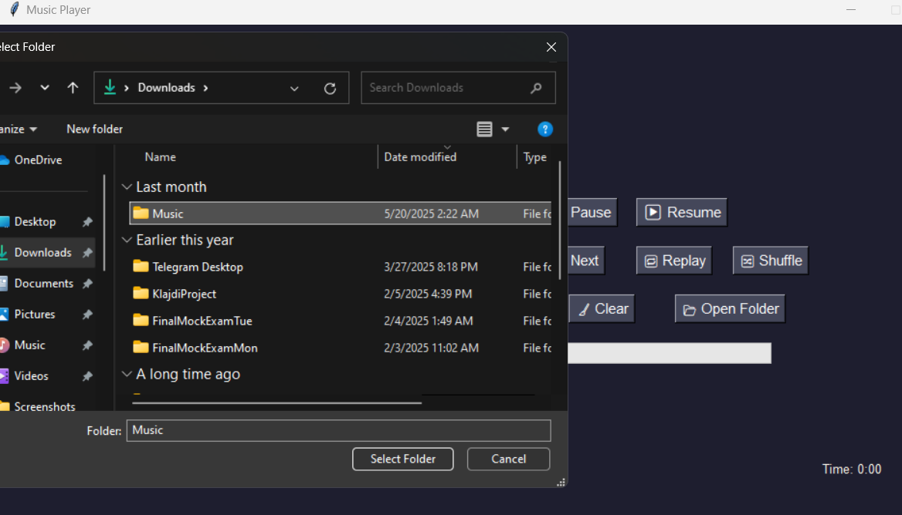
Play Song Select a song from the list and click "Play"
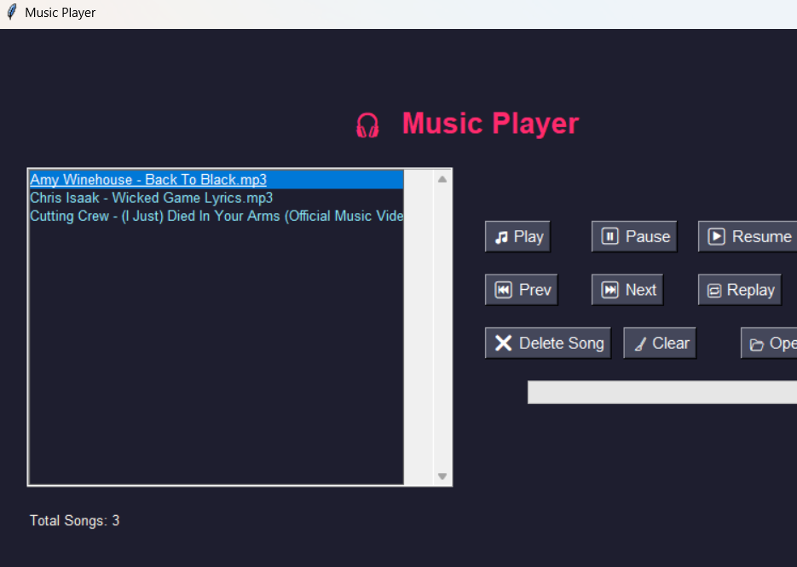
Pause Toggle pause for the current song

Resume Toggle resume for the current song
Next/Prev Use navigation buttons to jump between songs
Shuffle Mode Click to randomize playlist order
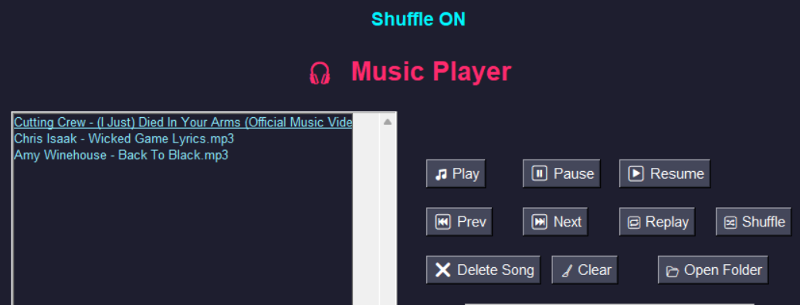

Replay Mode Enables looping the same song
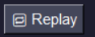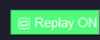
Delete Song Select a song and press "Delete" to remove from playlist
Song Count Display Shows how many songs are currently loaded
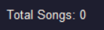
Clear playlist Clear the playlist by press “Clear”, the list with songs
